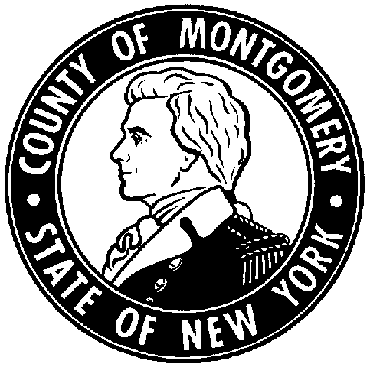 | RESOLUTION NO.  DATED:  RECOMMENDATION:

RESOLUTION AUTHORIZING THE COUNTY EXECUTIVE TO SIGN AGREEMENTS FOR SERVICES APPROVED IN 2021 (SOCIAL SERVICES)

Resolution by Legislator: | Seconded by:

WHEREAS, the Commissioner of Social Services, is required to enter into agreements with New York State approved providers for services to the aging population within Montgomery County; and
WHEREAS, the services provided are at the cost of the client(s) and are only mandated agreements; and
RESOLVED, the facilities that are used in Montgomery County are as follows:
- Community Hospice in Amsterdam
- Mountain Valley Hospice
- Nathan Littauer PERS
- Lifeline Systems
- RAMA Associates LLC dba Home Helpers and Direct Link
- Resource Center for Independent Living
- The Sentinel of Amsterdam
- Broadway (Simply the Best)
- Top Quality
- Visiting Nurses
FURTHER RESOLVED, that the Montgomery County Legislature, after review and approval by the County Attorney, hereby authorizes and directs the County Executive to sign, and execute prospective contract documents for a term of January 1, 2021 through December 31, 2021, entered into between the County and approved agencies providing services to County aging population in need of Personal Care Services, Assisted Living, Hospice, and Personal Emergency Response Systems.

Statement of Legislative and Financial Impact:
- Nature of Request:

Authorizing County Executive to sign state approved facilities agreements.

- Justification:

The Department is mandated to contract with state approved agencies to provide needed services to our aging population.

- Legislative Impact:

Pursuant to Article 3 of the Charter, the Montgomery County Executive has the authority to sign contracts.

- Financial Impact:

Agreements are for services for which DSS does not pay. We are contracting to facilitate program use for our clients who are Medicaid eligible.

